Birla Institute of Technology & Science - Pilani, Hyderabad Campus
First Semester 2012-2013
CS F211 / IS F211: Data Structures and Algorithms
Comprehensive Examination
Type: Part Open Time: 180 mins Max Marks: 120 Date: 02.05.2013

Read following instructions carefully:
- Question paper contains Part A (closed book) and Part B (open book).
- Two answer sheets will be provided to answer part A and Part B.
- Write name of the part (Part A / Part B) on the main page of the corresponding answer book.
- Answers to Part A questions should not be written in answer book of Part B and vice versa.
- You may take text / reference books to answer Part B questions only after submitting Part A answer sheet.
- You may submit Part A answer book at any time during 3 Hours.
Part A (Closed Book)
1.a. For all positive f(n), f(n) + o(f(n)) = Θ(f(n)). [True / False] [+1 0 -1 Mark]

1.b. Every problem in NP can be solved in exponential time. [True / False] [+1 0 -1 Mark]

1.c. Give a recurrence T(n) = _ _ _ for the running time of each of the following algorithms, along with the asymptotic solution to that recurrence:
i. Insertion sort
ii. Merge sort
Solve the resultant recurrence by master’s theorem. [4 Marks]

1.d. Given n integers in the range 0 … k, describe how to preprocess these integers into a data structure that can answer the following query in O(1) time: given two integers a and b, how many integers fall within the range a … b? [3 Marks]

1.e. Consider an array A[1 … n] of integers in the range 1 … n². A number a is a heavy hitter in A if a occurs in A at least n/2 times. Give an efficient algorithm of complexity O(n) that finds all heavy hitters in a given array A. [6 Marks]

1.f. Could a binary search tree be built using o(n logn) comparisons in the comparison model? Explain why or why not. [5 Marks]
2.a. Let T be a binary search tree, and x be a key. Give an efficient algorithm (of complexity O(h)) for finding the smallest key y in T such that y > x. Note that x may or may not be in T. Explain why your algorithm has the running time it does. [8 Marks]

2.b.Consider the following variation on Mergesort for large values of n. Instead of recursing until n is sufficiently small, recur at most a constant r times, and then use insertion sort to solve the 2^{r} resulting subproblems. What is the (asymptotic) running time of this variation as a function of n (and possibly r)? [3 Marks]
2.c.Give an O(n) time algorithm for computing the depth of all the nodes of a tree T, where n is the number of nodes of T. [4 Marks]

2.d. Sets are as fundamental to computer science as they are to mathematics. Whereas mathematical sets are unchanging, the sets manipulated by algorithms can grow, shrink, or otherwise change over time. We call such sets dynamic. Some dynamic sets presuppose that the keys are drawn from a totally ordered set, such as the real numbers, or the set of all words under the usual alphabetic ordering. A total ordering allows us to define the minimum element of the set, for example, or speak of the next element larger than a given element in a set.

SEARCH(S, k): A query that, given a set S and a key value k, returns a pointer x to an element in S such that key[x] = k, or NIL if no such element belongs to S.
INSERT(S, x): A modifying operation that augments the set S with the element pointed to by x. We usually assume that any fields in element x needed by the set implementation have already been initialized.
DELETE(S, x): A modifying operation that, given a pointer x to an element in the set S, removes x from S. (Note that this operation uses a pointer to an element x, not a key value.)
MINIMUM(S): A query on a totally ordered set S that returns a pointer to the element of S with the smallest key.
MAXIMUM(S): A query on a totally ordered set S that returns a pointer to the element of S with the largest key.
SUCCESSOR(S, x): A query that, given an element x whose key is from a totally ordered set S, returns a pointer to the next larger element in S, or NIL if x is the maximum element.

For each type of dynamic set (L) in the following table, what is the asymptotic running time for each operation listed, in terms of the number of elements n? For operations that have not been explicitly defined, consider how you would implement the operation given the data structure. You do not need to give the algorithm, just the running time. State any assumptions that you make. Assume that the hash tables resolve collisions by chaining with doubly linked lists.
[+15 0 -15]

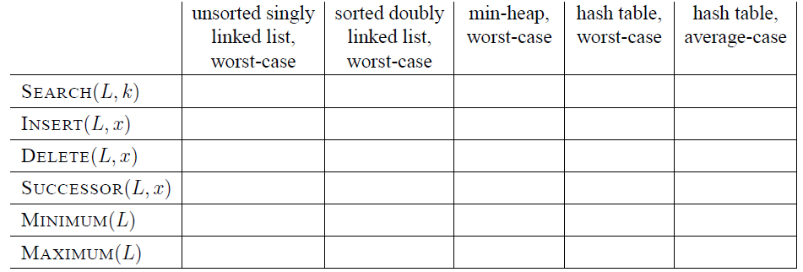

3..a. Suppose we want to make change for n cents, using the least number of coins of denominations 1, 10, and 25 cents. Describe an O(n) dynamic programming algorithm to find an optimal solution. (There is also an easy O(1) algorithm but the idea here is to illustrate dynamic programming.) [4 Marks]

3.b. [8 Marks]
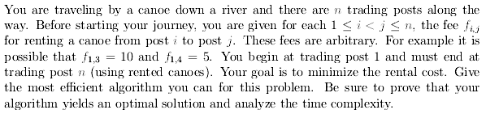
3.c. [8 Marks]
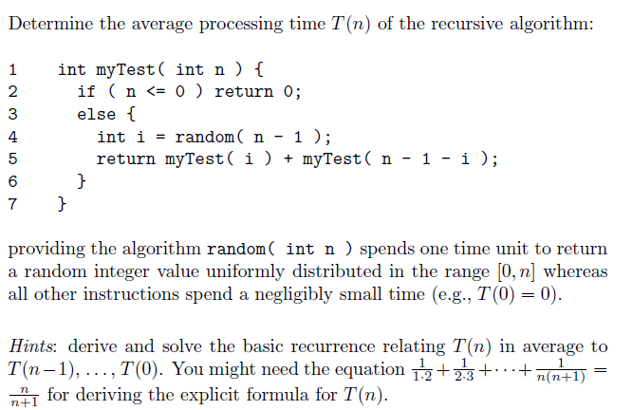

4.a. Explore the backtracking technique to solve the following problem. S= {5,10,12,13,15,18}, Find a subset of S such that sum of its elements should be equal to 30. [8 Marks]

4.b. Find the shortest distance between source (A) and all other vertices in below mentioned graph by exploring Dijkstra’s algorithm. [6 Marks]

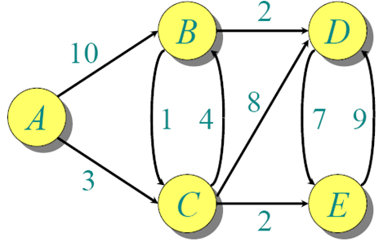
4.c. On a positive integer, you can perform any one of the following 3 steps. 1) Subtract 1 from it. ( n = n - 1 ) , 2) If its divisible by 2, divide by 2. ( if n % 2 == 0 , then n = n / 2 ) , 3) If its divisible by 3, divide by 3. ( if n % 3 == 0 , then n = n / 3 ). Now the question is, given a positive integer n, devise an algortihm that takes minimum number of steps that takes n to 1.
eg: 1.)For n = 1 , output: 0 2.) For n = 4 , output: 2 ( 4 /2 = 2 /2 = 1 )
3.) For n = 7 , output: 3 ( 7 -1 = 6 /3 = 2 /2 = 1 ) [6 Marks]

Part B (Open Book)
5.a. [5 + 5 Marks]
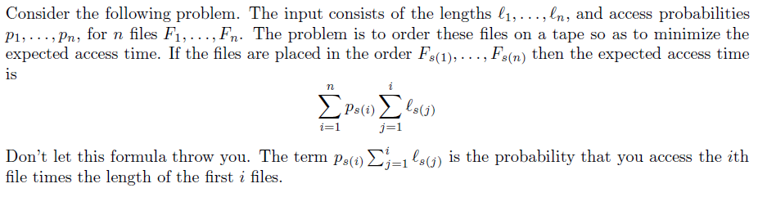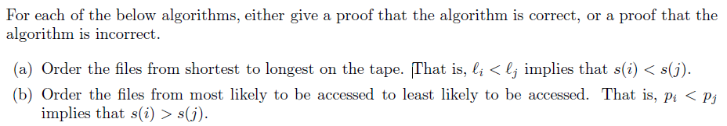
5.b. [10 Marks]
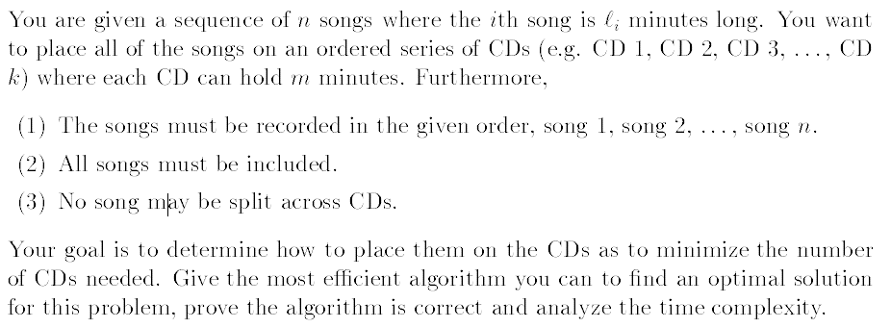
6.a.The diameter of a tree T = (V,E) is given by [10 Marks]
max δ(u, v)
u,v∈V
where δ(u, v) is the number of edges on the path from u to v.
Describe an efficient algorithm by exploring dynamic programming technique to compute the diameter of a tree, and show the correctness and analyze the running time of your algorithm.

